- Write a program to perform Classification using K-means.
# Loading data
data(iris)
# Structure
str(iris)
'data.frame': 150 obs. of 5 variables:
$ Sepal.Length: num 5.1 4.9 4.7 4.6 5 5.4 4.6 5 4.4 4.9 ...
$ Sepal.Width : num 3.5 3 3.2 3.1 3.6 3.9 3.4 3.4 2.9 3.1 ...
$ Petal.Length: num 1.4 1.4 1.3 1.5 1.4 1.7 1.4 1.5 1.4 1.5 ...
$ Petal.Width : num 0.2 0.2 0.2 0.2 0.2 0.4 0.3 0.2 0.2 0.1 ...
$ Species : Factor w/ 3 levels "setosa","versicolor",..: 1 1 1 1 1 1 1 1 1 1 ...
# Installing Packages
install.packages("ClusterR")
install.packages("cluster")

# Loading package
library(ClusterR)
library(cluster)
# Removing initial label of
# Species from original dataset
iris_1 <- iris[, -5]

# Fitting K-Means clustering Model
# to training dataset
set.seed(240) # Setting seed
kmeans.re <- kmeans(iris_1, centers = 3, nstart = 20)
kmeans.re
K-means clustering with 3 clusters of sizes 50, 62, 38

Cluster means:
Sepal.Length Sepal.Width Petal.Length Petal.Width
1 5.006000 3.428000 1.462000 0.246000
2 5.901613 2.748387 4.393548 1.433871
3 6.850000 3.073684 5.742105 2.071053

Clustering vector:
[1] 1 1 1 1 1 1 1 1 1 1 1 1 1 1 1 1 1 1 1 1 1 1 1 1 1 1 1 1 1 1 1 1 1 1 1 1 1 1 1
[40] 1 1 1 1 1 1 1 1 1 1 1 2 2 3 2 2 2 2 2 2 2 2 2 2 2 2 2 2 2 2 2 2 2 2 2 2 2 2 3
[79] 2 2 2 2 2 2 2 2 2 2 2 2 2 2 2 2 2 2 2 2 2 2 3 2 3 3 3 3 2 3 3 3 3 3 3 2 2 3 3
[118] 3 3 2 3 2 3 2 3 3 2 2 3 3 3 3 3 2 3 3 3 3 2 3 3 3 2 3 3 3 2 3 3 2

Within cluster sum of squares by cluster:
[1] 15.15100 39.82097 23.87947
(between_SS / total_SS = 88.4 %)

Available components:

[1] "cluster" "centers" "totss" "withinss" "tot.withinss"
[6] "betweenss" "size" "iter" "ifault"
# Cluster identification for
# each observation
kmeans.re$cluster
[1] 1 1 1 1 1 1 1 1 1 1 1 1 1 1 1 1 1 1 1 1 1 1 1 1 1 1 1 1 1 1 1 1 1 1 1 1 1 1 1
[40] 1 1 1 1 1 1 1 1 1 1 1 2 2 3 2 2 2 2 2 2 2 2 2 2 2 2 2 2 2 2 2 2 2 2 2 2 2 2 3
[79] 2 2 2 2 2 2 2 2 2 2 2 2 2 2 2 2 2 2 2 2 2 2 3 2 3 3 3 3 2 3 3 3 3 3 3 2 2 3 3
[118] 3 3 2 3 2 3 2 3 3 2 2 3 3 3 3 3 2 3 3 3 3 2 3 3 3 2 3 3 3 2 3 3 2
# Confusion Matrix
cm <- table(iris$Species, kmeans.re$cluster)
cm
1 2 3
setosa 50 0 0
versicolor 0 48 2
virginica 0 14 36
plot(iris_1[c("Sepal.Length", "Sepal.Width")])
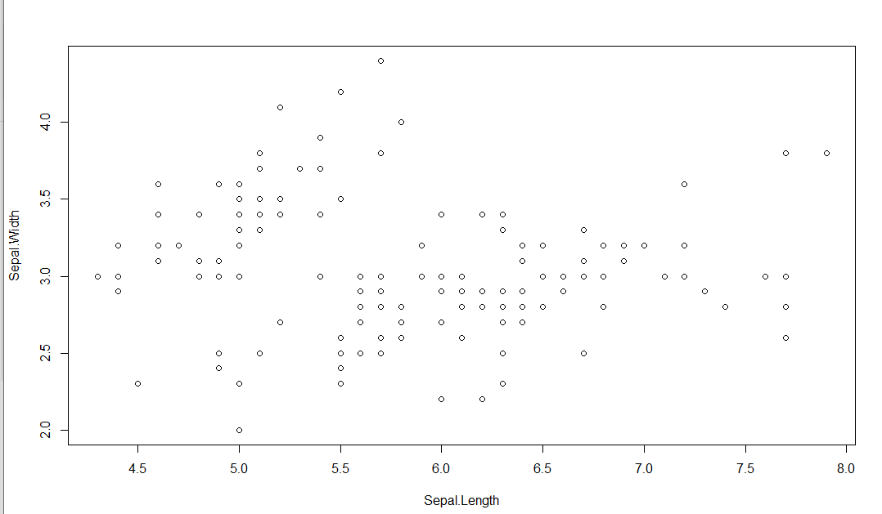
plot(iris_1[c("Sepal.Length", "Sepal.Width")],
col = kmeans.re$cluster)
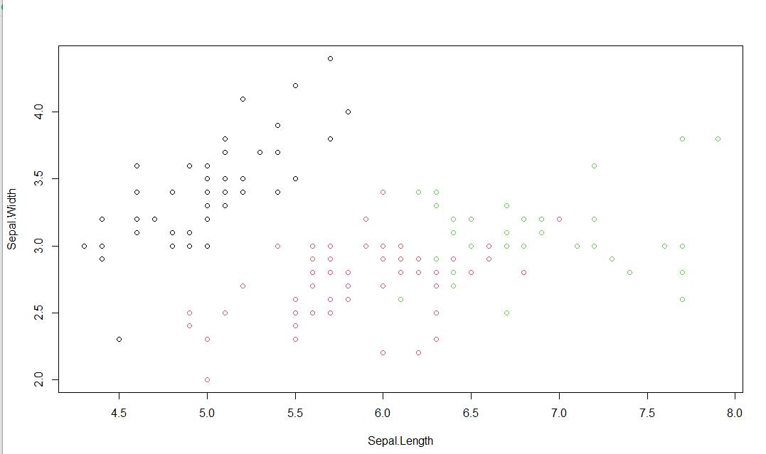
plot(iris_1[c("Sepal.Length", "Sepal.Width")],
col = kmeans.re$cluster,
main = "K-means with 3 clusters")
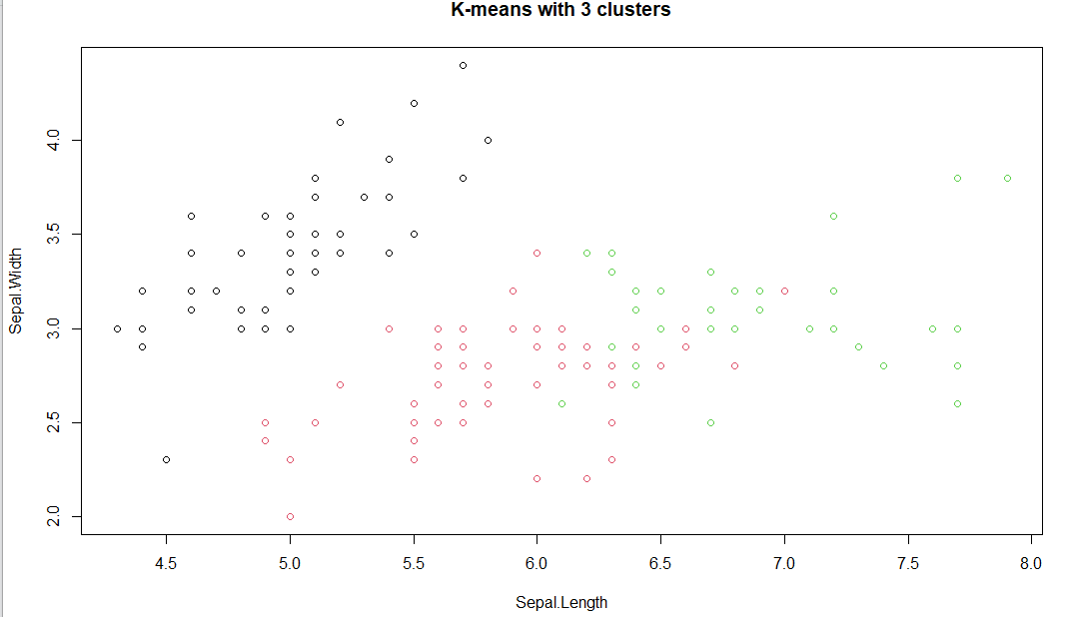
## Plotiing cluster centers
kmeans.re$centers
Sepal.Length Sepal.Width Petal.Length Petal.Width
1 5.006000 3.428000 1.462000 0.246000
2 5.901613 2.748387 4.393548 1.433871
3 6.850000 3.073684 5.742105 2.071053
kmeans.re$centers[, c("Sepal.Length", "Sepal.Width")]
Sepal.Length Sepal.Width
1 5.006000 3.428000
2 5.901613 2.748387
3 6.850000 3.073684
# cex is font size, pch is symbol
points(kmeans.re$centers[, c("Sepal.Length", "Sepal.Width")],
col = 1:3, pch = 8, cex = 3)
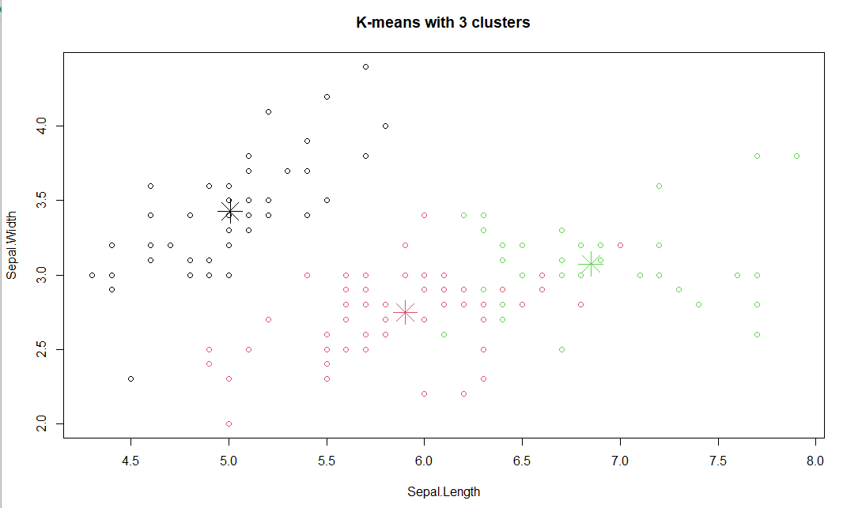 ## Visualizing clusters
y_kmeans <- kmeans.re$cluster
clusplot(iris_1[, c("Sepal.Length", "Sepal.Width")],
y_kmeans,
lines = 0,
shade = TRUE,
color = TRUE,
labels = 2,
plotchar = FALSE,
span = TRUE,
main = paste("Cluster iris"),
xlab = 'Sepal.Length',
ylab = 'Sepal.Width')
